2014 2nd International Conference on Computer, Electrical, and Systems Sciences, and Engineering (CESSE 2014), December 8-9, 2014, Singapore

**Design and implementation of university fixed assets management system**

Li Zheng

*Shandong Women's University, Jinan, Shandong, 250000, China*

# Abstract

This paper uses the J2EE framework, and proposed the development methods of the fixed assets management system in the Spring platform and the Struts. At the same time, the paper elaborates on the fixed assets management system under the framework of Spring and Struts technology, and lists some core code and part function description. Through the operation of the system many times, proved that the technology can improve the safety and stability of the system, both the Spring and the Struts framework also made redundant code of the system to reduce, avoid the waste of resources, which make the system have better scalability and maintainability.

*Keywords: University fixed assets management; J2EE; the Struts2; Spring Framework.*

# Instructions

With the continuous development of computer technology, information management has penetrated into all fields. How to use computer system to conveniently store information and manage fixed assets in university is the primary problem to realize the informationization in many colleges at the present stage. At present, Information management system uses comprehensive computer technology, information technology, management theory and control theory and modern management thoughts, methods and means of organic combine, which can assist the university management personnel of scientific management and decision-making, reduce waste in fixed assets in Colleges and universities, improve the reuse rate of fixed assets in Colleges and universities. The paper analyzes in detail the flow of the fixed assets management system in Colleges and universities, and points out some problems existing in the

978-1-61275-075-0/10/$25.00 ©2014 IERI CESSE 2014

management of fixed assets of University, and makes a deep research on the development of necessity of fixed assets management system in Colleges and universities.

In recent years, J2EE (Java 2 Platform Enterprise Edition) technology platform has been rapidly developed, and has become the development norms and application standards in the enterprises and institutions. J2EE technology platform collect service, protocol and application programming interface, using technology platform can construct a distributed multi-tier application, provide high stability, high robustness for system service. In Web application, the J2EE platform is divided into five levels, respectively, client layer, presentation layer, business layer, persistence layer and database layer. This architecture provides a new method for the development of a modular, component-based for developers. For the characteristics of J2EE technology, the system used Spring and Struts of J2EE technology framework to develop college fixed assets management system, analyzed the disadvantages of the fixed assets management system, according to the actual demand of colleges and universities, realize the data transfer between pages and logic business by MVC model. Design of various business logic classes, database connection using Spring JDBC can improve the safety and stability of the system. At the same time, the use of Spring and Struts framework that make the system fewer redundancy code, improving the system

scalability and maintainability.

# The design of the fixed assets management system

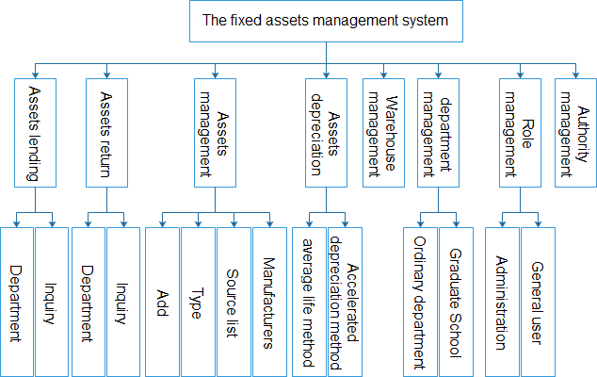According to the relationship between the system requirements analysis and each module of the system, the system can be divided into several modules asset lending, restitution of assets, asset management, depreciation management, department management, role management etc. The Fig.1 is the main framework of the system diagram.

Fig.1. The main frame diagram of system

The main functions include:

* 1. The fixed assets management: lending assets, assets restitution, assets depreciation, assets management;
  2. The basic information management: warehouse management, school management, fixed assets management, information source management;
  3. Fixed assets inquiry: assets increase query, query personal borrowing, assets change overall query;
  4. Depreciation management: average service life method, accelerated depreciation method;
  5. The staff management: role management, authority management;

# The fixed assets management process in university

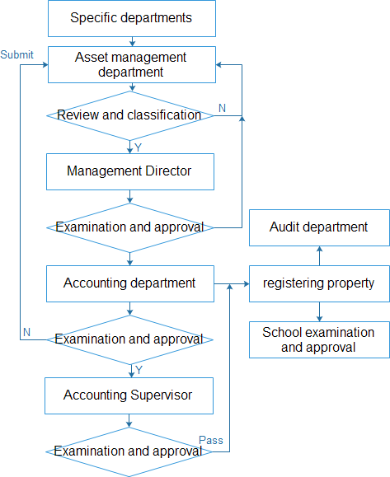Specific assets departments in Colleges and universities are used and manage object department. It is responsible for instructions and object management; asset management department is the asset management sector, they mainly manage fixed assets, the various types of card, the real import and include; the accounting department is the fund management department and make various financial assets certificate; the leadership of the responsible departments be responsible to examine and approval, supervise and inspect fixed assets business in itself Department, the process is as shown in Fig.2

Fig.2. The management process of fixed assets in college

# Design of class and the analysis of system structure

Based on the three layer structure, combining the actual situation of university assets management, overall structure frame is as shown in Fig.3.

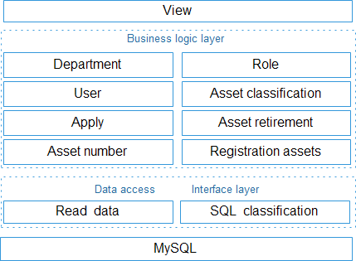Through the page access layer (View), business logic layer, Spring JDBC framework design and application as well as the breakdown of the data layer enable the whole management system more clear, the program more convenient in the operation and maintenance.

Fig.3. The system structure diagram

## MVC mode in page display layer

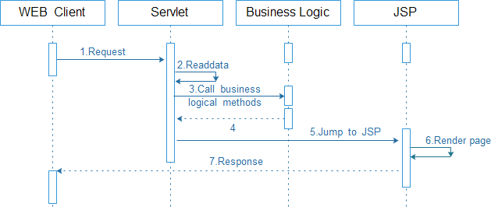Display layer is that the user can see and interact with the interface [1]. The display layer shows the related data through the JSP page, and can accept user related input data, but the display business processing, display layer cannot be the actual to user interface synchronization update. The display layer has two main functions, one is friendly, the second is the user and system interaction in this part mainly uses Struts to achieve MVC (Model View Controller) model [2-5. The application of MVC mode is input into the asset information, processing data, output the asset information; it is as shown in Fig.4.

Fig.4. MVC design mode

## Business logic layer

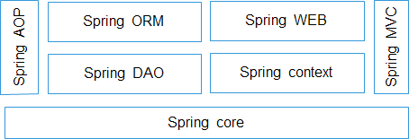Spring is an open source framework [5] created by Rod Johnson Spring, its framework is composed of 7 modules, which are shown in Fig.4.

Fig.5. Spring Architecture diagram

# System implementation

## The assets management

The fixed assets management system will realize the asset management function, basic statistics and query functions. The host operating system interface is composed of asset management, personnel management and basic maintenance page.

## Assets add

Assets add is the basis of the system to add data, only the asset data be recorded into the system, in order to realize function of assets such as adding, classification, query management etc..

## The realization of assets depreciation class

Now we take DepreciationDispatchAction.java as example, the first to verify whether the user login, and then obtain the depreciation Depreciation method choice object, used for acquiring assets from the form, price, age, depreciation amount etc.. In this case, is mainly to depreciation average life method, finally completed by depreciation of assets depreciation average life formula [5].

public ActionForward check( ActionMapping mapping, ActionForm form, HttpServletRequest request, HttpServletResponse response)

throws Exception { BaseDispatchAction.isLogon( request, response) ; String id = request.getParameter( " id" ) ;

if ( id ! = null id.trim( ) .length( ) > 0) { DepreciationDAO dao = new DepreciationDAO( ) ;

Depreciation depreciation = dao.findById (Integer.valueOf ( id) ) ; DepreciationForm depreciationForm = new DepreciationForm( ) ; if ( " average" .equals( depreciation.getArithmetic( ) ) ) {

Asset asset = depreciation.getAsset( ) ; double price = asset.getPrice( ) ;

int life = asset.getLife( ) ;

Double everyYearSum = price / life;

Double everyMonthSum = everyYearSum / 12;

}

else if ( " speedup" .equals( depreciation. getArithmetic( ) ) )

{ saveMessage(request," depreciationForm. Speedup. null" ) ; }

}

return mapping.findForward( " check" ) ;

}

# Conclusions

This system mainly around the Spring and Struts two framework to develop, it can solved many problems of difficult tests, data query and visited slow in J2EE program development. To realize the system business logic layer and data persistence layer using MVC mode, DAO mode, Spring JDBC read separately, improve code reuse rate in the program development process; at the same time, using two framework technologies makes the system integration code in the development process, and improve high efficiency in the program development modules. The system has greatly improved efficiency in the increase, delete, change and check.

# References

1. Cui Jun. Design and implementation of fixed assets management system [D].

Jiangxi: Nanchang University, 2009

1. Song Mei, Zhang Xue Ping Ze. The principle of J2EE explain profound theories in simple language application architecture design and deployment [M]. Beijing: Tsinghua University press, 2006198-201.
2. Li Jun. Research and development of college fixed assets management system based on WEB [D]. Beijing: China University of Geosciences, 2008
3. Wang Shuang, the real Dingyi, Chen Xiaojiang. The design and implementation of network examination system based on J2EE [J]. Computer technology and development, 2008, 6 (10): 155-157.
4. Zhao Di, the package Daheng, Han Qian. Discussion of some problems in the management of fixed assets in Institutions [J]. China management information (Comprehensive Edition), 2008, 10 (12): 5-7.